**Change Proxmox Logo and web I cone**

Logo size:

Width: 172px

Height: 30px

proxmox_logo.png

Web I cone:

Width: 128px

Height: 128px

logo-128.png

**Change image location: Proxmox Gateway server**

root@mailgw:~# **cd /usr/share/javascript/pmg-gui/images/**

root@mailgw:/usr/share/javascript/pmg-gui/images# **ls**

logo-128.png proxmox_logo.png proxmox_logo.png.bac

**### Change vimbadmin Web Admin Pannel.**

Image Location vimbadmin

[root@mail images]# **cd /usr/share/nginx/html/vimbadmin/public/images/**

-rwxrwxrwx 1 nginx nginx logo_500x159.jpg

Image Name: logo_500x159.jpg

Image Size:

Width: 500px

Height: 159px

Image Name: favicon.ico

Location: [root@mail images]# **cd /usr/share/nginx/html/vimbadmin/public/**

Image Size:

Width: 16px

Height: 16px

**Group Change and full Permission.** // Same Group Permission All Icone Logo

[root@mail images]# **chown -R nginx:nginx logo_500x159.jpg**

[root@mail images]# **chmod 777 logo_500x159.jpg**

[root@mail images]# **systemctl restart mysqld.service postfix nginx php-fpm dovecot**

**Vimbadmin Footer Change option:**

[root@mail views]# **cd /usr/share/nginx/html/vimbadmin/application/views/_skins/myskin**

[root@mail views]# **vim footer.phtml**

[root@mail views]#**cd /usr/share/nginx/html/vimbadmin/application/views**

[root@mail views]# **vim footer.phtml**

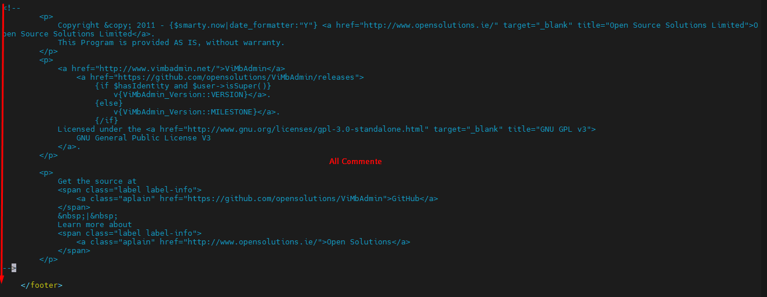

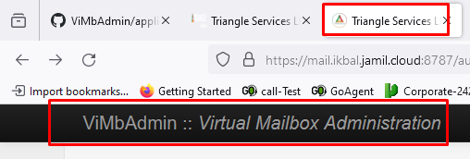

[root@mail views]# cd /usr/share/nginx/html/vimbadmin/application/views

[root@mail views]# vim header.phtml

[root@mail views]# systemctl restart nginx

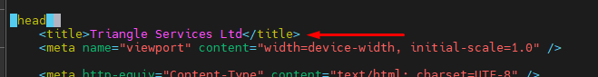

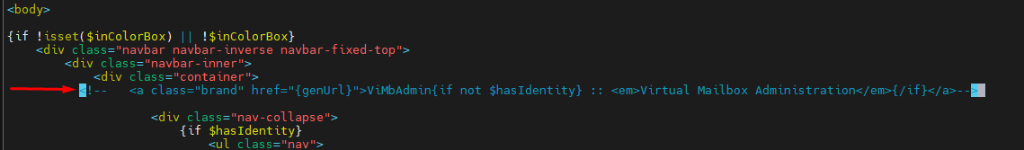

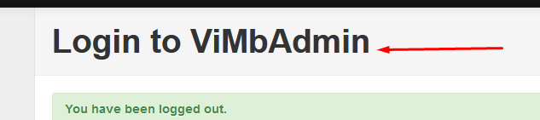

[root@mail auth]# cd /usr/share/nginx/html/vimbadmin/application/views/auth

[root@mail auth]# vim login.phtml

[root@mail auth]# systemctl restart nginx

